Summary

The goal of this project is to study the effects of age, sex, Karnofsky performance score rated by physician, Karnofsky performance score rated by patient, ECOG performance score, calories consumed at meals and weight loss in last six months on the survival time of advanced lung patients. The analysis shows that age, ECOG performance score and Karnofsky performance score rated by patient are three significant factors affect the survival time. Specifically, if we hold ECOG performance score, Karnofsky performance score rated by patient fixed, male patients with advanced lung cancer are about 1.74 times more likely die than female patients with advanced lung cancer. If we hold sex and Karnofsky performance score rated by patient fixed, then increase ECOG performance score by one, the probability of death becomes 74% than before. If we hold sex and ECOG performance score, then increase Karnofsky performance score rated by patient by one, the probability of death becomes 2.24% than before.

Introduction

As one of the common types of cancer, lung cancer leads to millions of deaths every year. According to the table of age-standardized net survival for patients diagnosed with lung cancer during 2010-2011 in England and Wales prepared by Cancer Research UK, 32% of adults survive lung cancer for at least one year and it is predicted to fall to 8.8% for five years or more.

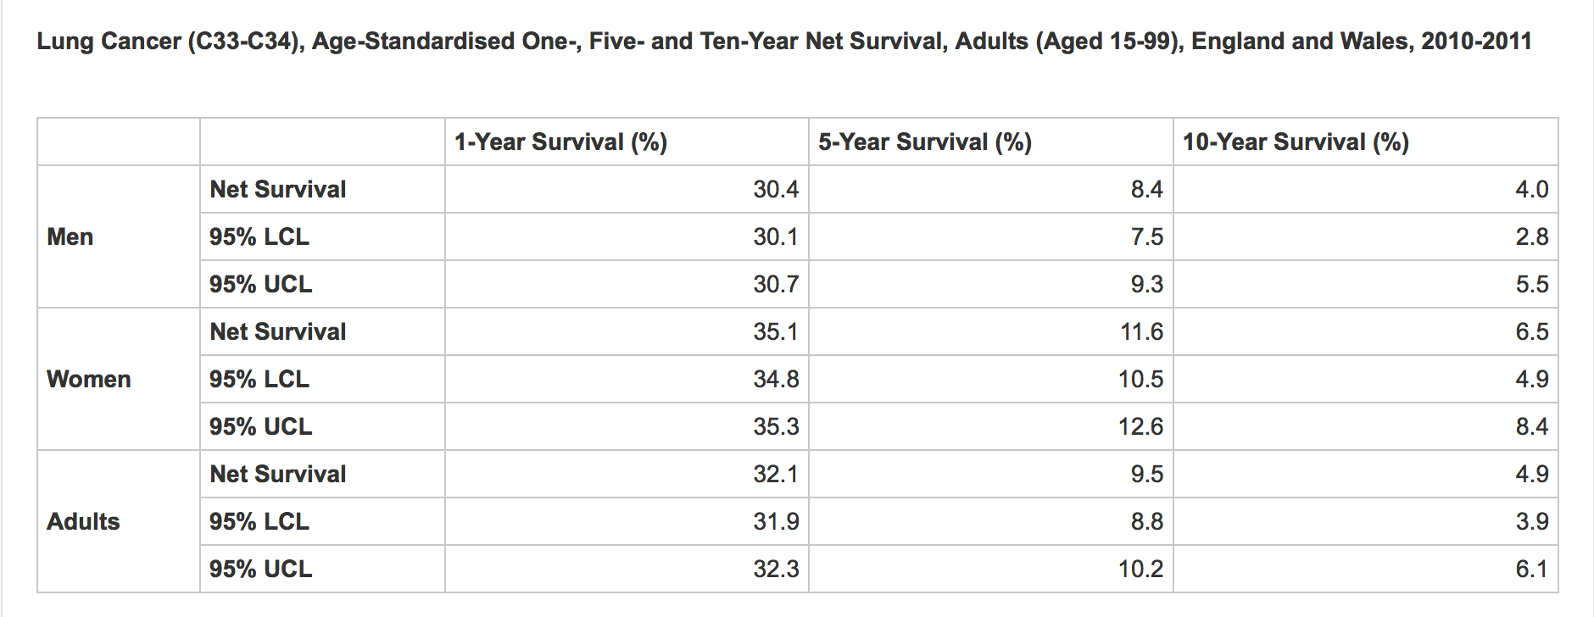

Based on the definition of lung cancer staging provided by Cancer Research UK, stage four A and B with symptoms like cancer in both lungs and cancer spread to one or more organs is normally called advanced lung cancer. Several factors could affect the survival time of advanced lung cancer patients and our project uses a lung cancer data set to analyze which ones are potentially significant and to what extent they would affect the survival time of patients.

The data set used for this project comes from the North Central Cancer Treatment Group. It has been originally presented and analyzed in Lprinzi et al.(1994). Prospective evaluation of prognostic variables from patient-completed questionnaires. North Central Cancer Treatment Group. *Journal of Clinical Oncology: Official Journal of the American Society of Clinical Oncology*, 12(3), 601-607. It records the survival status of patients with advanced lung cancer and several performance features of patients, including age, sex, ECOG performance score, Karnofsky performance score rated by physician, Karnofsky performance score rated by patient, calories consumed at meals and weight loss in last six months.

<http://www.cancerresearchuk.org/health-professional/cancer-statistics/statistics-by-cancer-type/lung-cancer/survival#heading-Zero>

<http://www.cancerresearchuk.org/about-cancer/lung-cancer/stages-types-grades>